Protect Our Manoomin is a non-profit, grassroots Anishinaabe organization. Our mission is to educate and provide outreach on issues related to manoomin (wild rice) in regard to mining, environmental ethics, and associated treaty rights issues.

For more information, visit our website at:

[www.protectourmanoomin.org](http://www.protectourmanoomin.org)

For information on speakers, contact:

r_desjarlait@protectourmanoomin.org

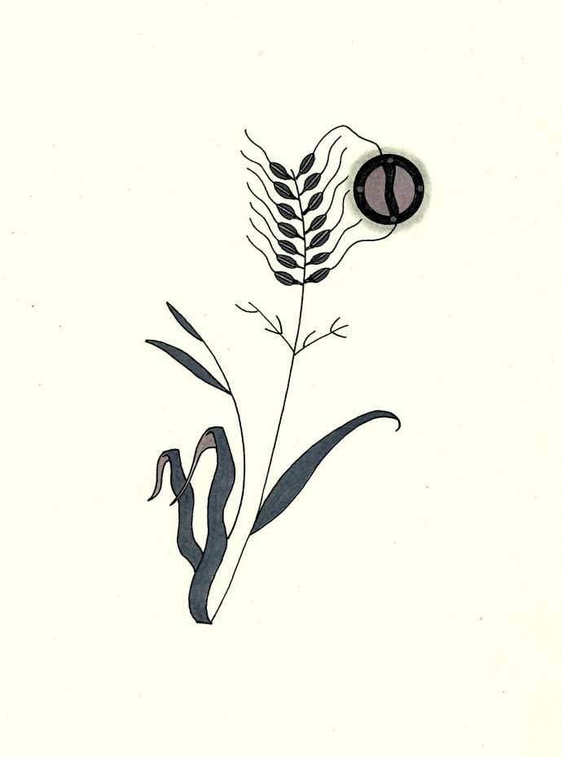

**A Protect Our Manoomin Primer**

**on PolyMet and Sulfide Mining**

* PolyMet is a foreign, Canadian extractive resource entity backed by Swiss multinational Glencore. Glencore has been cited for human rights abuses in the Congo and Columbia. Glencore currently owns about a quarter of PolyMet stock. Most of the copper from PolyMet’s mine will be exported to China.
* EPA: “According to [PolyMet’s) DEIS [Draft Environmental Impact Study], all waste rock at the site is acid generating, and acidic water moving through waste rock and tailings will mobilize metals and sulfates, leaching them into groundwater and surface water…based on our review of the DEIS, EPA has rated the DEIS as environmentally Unsatisfactory – Inadequate. Environmentally Unsatisfactory (EU) indicates that our review has identified adverse environmental impacts that are of sufficient magnitude that EPA believes that the proposed action must not proceed as proposed.” (EPA Letter / February 2010).
* The proposed mine site is within the Superior National Forest, where open pit strip mining is not allowed under the Weeks Act. Under a new streamlining law passed in 2011, Iron Range Resources and Rehabilitation Board (IRRRB) provided PolyMet with a $4 million loan to buy land that will, in turn, be exchanged for Superior National Forest land. PolyMet will take about 6,700 acres of public land from the Superior National Forest. The mine will directly destroy more than 850 acres of high-quality wetlands with more than 650 additional acres of wetlands indirectly impaired. The total wetlands impact will be more than 1,500 acres. The vast majority of the required wetlands mitigation will occur outside the St. Louis River watershed
* The mine is expected to generate nearly 400 million tons of waste rock and account for an annual carbon footprint of 767,648 metric tons of carbon dioxide emissions. Reactive waste rock piles will be permanently left on the land – ranging in size from 70 to 560 acres in size, and from 13 to 20 stories high.

*FAQs cited adapted from several sources including Protect Our Manoomin,*

*WaterLegacy, Friends of the BWCA, and Lake Superior Mining News.*

* The project proposes to store mine tailings and toxic waste materials in an existing mine tailings basin that has current basin stability problems. The existing basin is located at Hoyt Lakes – 50 miles from Duluth.
* According PolyMet’s DEIS, primary water treatment would need to continue for 2000 years.
* The mine site is located within the 1854 Treaty Ceded Territory, where the Bois Forte, Fond du Lac, and Grand Portage Anishinaabeg Nations retain hunting, fishing and gathering reserved treaty rights as affirmed under the Voigt Decision (1983).
* There is approximately 64,000 acreage of manoomin in Minnesota; 48,000 acres are located within tribal ceded lands. There are 1800 acres of manoomin in the Hoyt Lake area, where Polymet will build their mine.
* Manoomin (natural wild rice) has enormous ecological value - protecting water quality, reducing algae blooms, and providing habitat for fish, mammals and wildfowl.
* Minnesota’s Wild Rice/Sulfate Water Quality Standard is 10 milligrams per liter (mg/L). This standard protects tribal resources, manoomin and the manoomin ecosystem.
* Sulfates are released from waste rock, enter into the water, and settle into the sediment where it converts to hydrogen sulfide. Hydrogen sulfide enters into the manoomin root system and results in smaller seeds and yellowed leaves. High concentrations of hydrogen sulfides suffocate and kill the plant.
* Additionally, high sulfate concentrations create high risk situations for mercury methylation. Methyl mercury is the active form of mercury that accumulates in fish and is toxic to humans and wildlife.
* Manoomin is a vital cultural, spiritual, economic, and food resource for the Anishinaabe people.