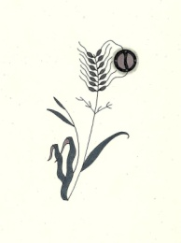
Protect Our Manoomin
For the Present Generation to the Seventh Generation
PETITION FOR PROTECTING OUR MANOOMIN
Whereas Non-Ferrous Mining (also referred to as Sulfide Mining) is known to damage and destroy manoomin stands by releasing sulfates into the waters, we the undersigned support efforts to protect manoomin and the environment.

Name | Signature | Address  (City, state, zip) | E-mail
Please note: We do not share our lists with other organizations. For more information on our work, please visit our website at www.protectourmanoomin.org. Mii’gwech

