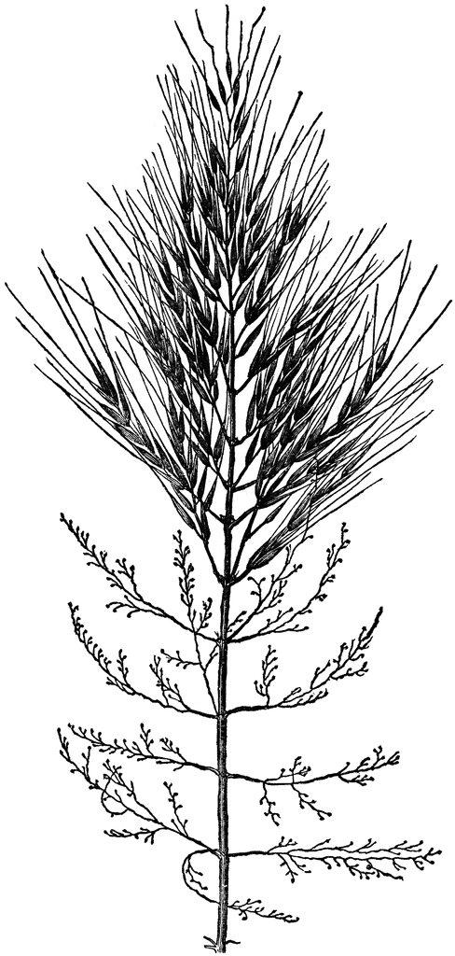
Wild Rice
Prophecy
Resource
Protect It
For The Seventh Generation
For more information, visit www.protectourmanoomin.org
Wild Rice
Prophecy
Resource
Protect It
For The Seventh Generation
For more information, visit www.protectourmanoomin.org

Wild Rice
Prophecy
Resource
Protect It
For The Seventh Generation
For more information, visit www.protectourmanoomin.org

