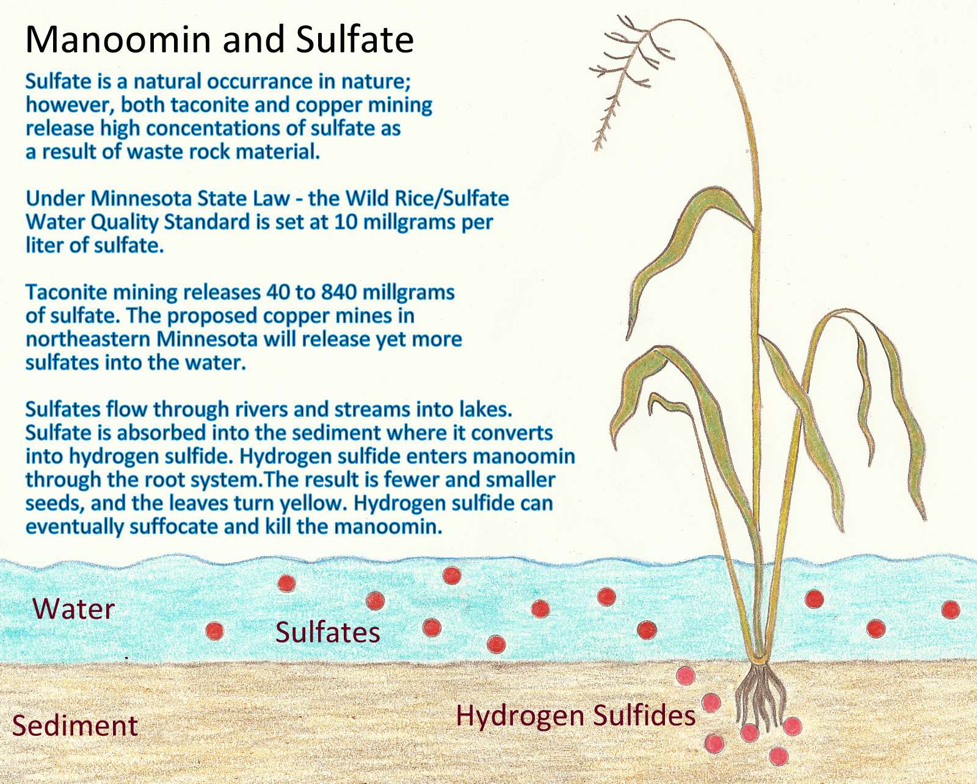

According to PolyMet’s Environmental Impact Study, it will take two-thousand years for the water to return to the quality when the mining began. These are the waters of our Ceded Territory. How will this affect the quality of our manoomin, and the quality of the animals we hunt and fish?

Current taconite mines:

* Minntac
* Keetac

Copper mining companies that

are proposing mining:

* PolyMet
* Twin Metals
* Teck
* Cardero
* Kennecott/Rio Tinto (Aitkin

and Carlton Counties)

© **Protect Our Manoomin, 2011**